Topic: Portfolio Project Module 8

Tripti Vishwakarma
Colorado State University Global
Course Code: CSC500-1
Steven Evans
May12 2024

The Online Shopping Cart project is a multi-faceted programming exercise which we designed to simulate the functionality of an e-commerce shopping cart system. Through a series of milestones, we incrementally built a program that can handle various operations commonly found in online shopping experiences.

Milestone 1:
We begin by creating the `ItemToPurchase` class, which serves as the blueprint for items that can be added to the shopping cart. This class includes attributes for the item's name, price, and quantity, with a default constructor setting these values to "none", 0, and 0, respectively. The class also contains a `print_item_cost` method that displays the cost for each item, accounting for its quantity.

As a practical application, the main section of the code prompts users to input data for two items, creating `ItemToPurchase` objects with the provided details. The total cost of these two items is then calculated and displayed, giving users an initial interaction with the cart's cost aggregation capabilities.

Milestone 2:
With the item class established, the focus shifts to building the `ShoppingCart` class. This class features a parameterized constructor and attributes including the customer's name, the current date, and a list to hold `ItemToPurchase` objects. Essential methods such as `add_item`, `remove_item`, `modify_item`, `get_num_items_in_cart`, `get_cost_of_cart`, `print_total`, and `print_descriptions` are introduced to manage the cart's items and their attributes.

A `print_menu` function is implemented to output a menu of options that allow users to interact with the shopping cart by adding, removing, or modifying items, as well as displaying the cart's contents or the items' descriptions. This menu-driven interface is designed to handle user input until the 'quit' option is selected.

Final Project Submission:
For the final submission, we enhance the main section of the code by prompting users for the customer's name and today's date, which are used to instantiate a `ShoppingCart` object. Additional functionality is integrated, enabling users to add items with their descriptions to the cart, remove items, and change the quantity of existing items. Each of these tasks requires careful handling of user input and manipulation of the shopping cart's state.

The project culminates in compiling and submitting all components—pseudocode, source code, and application execution screenshots—along with documentation of the results and a Git repository containing the project's version history. This comprehensive submission showcases our ability to develop a functional and user-interactive application using object-oriented programming principles.

Matthes, E. (2019). Python Crash Course (2nd ed.). No Starch Press.

Sweigart, A. (2020). Automate the Boring Stuff with Python (2nd ed.). No Starch Press.

Barry, P. (2016). Head First Python (2nd ed.). O'Reilly Media.

Python Software Foundation. (n.d.). Python 3.9.1 documentation. https://docs.python.org/3/

W3Schools.com. (n.d.). Python Tutorial. https://www.w3schools.com/python/

Below is the source code –
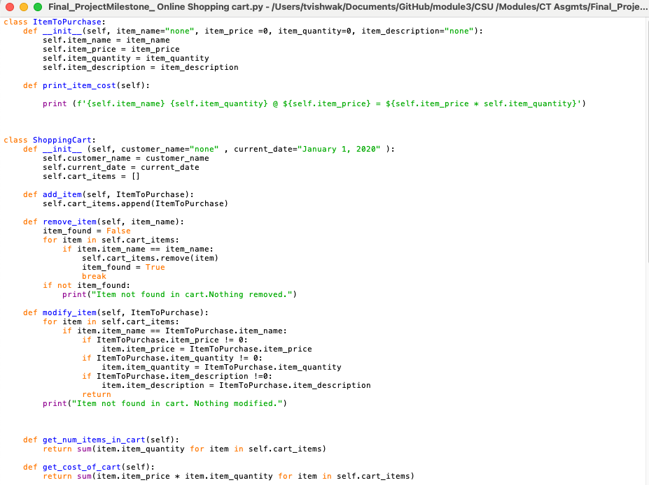

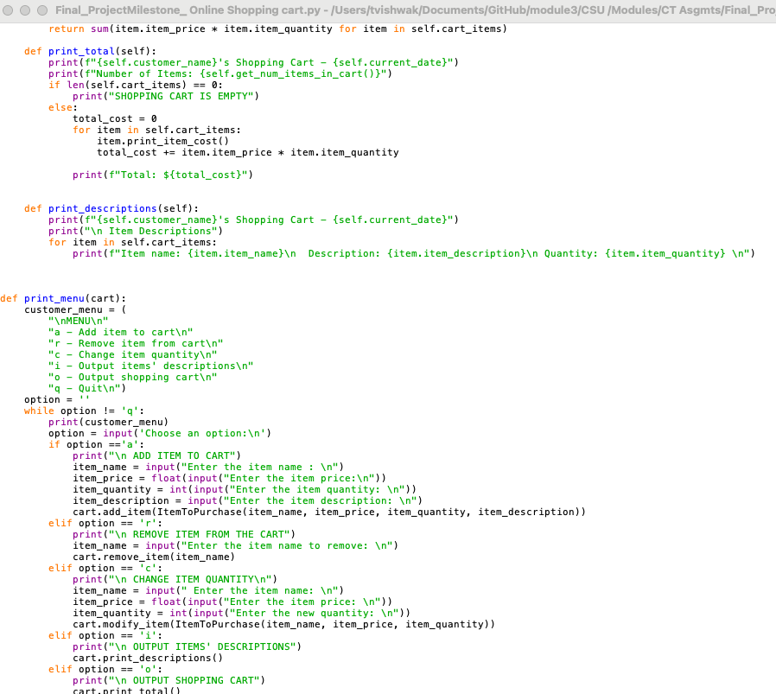

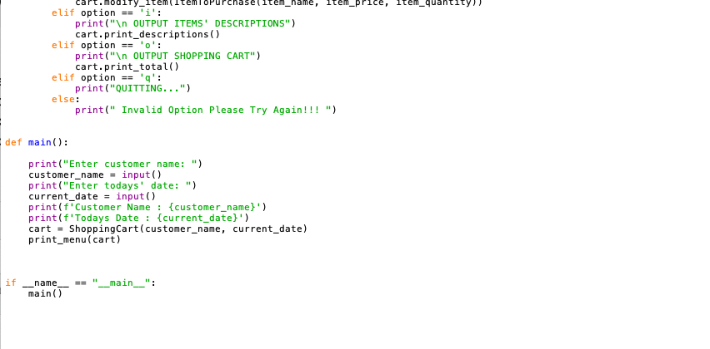

Below is the code execution –
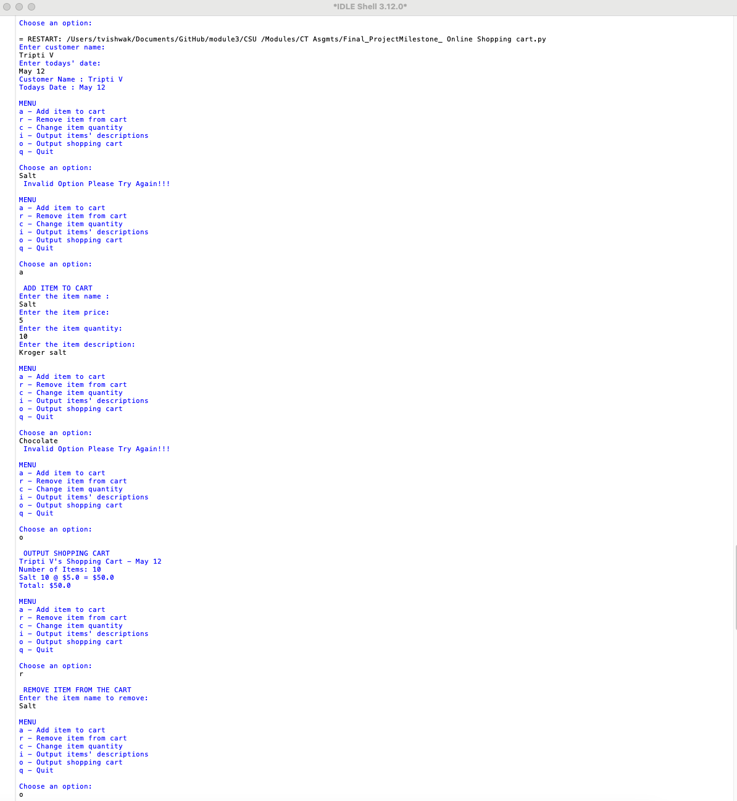

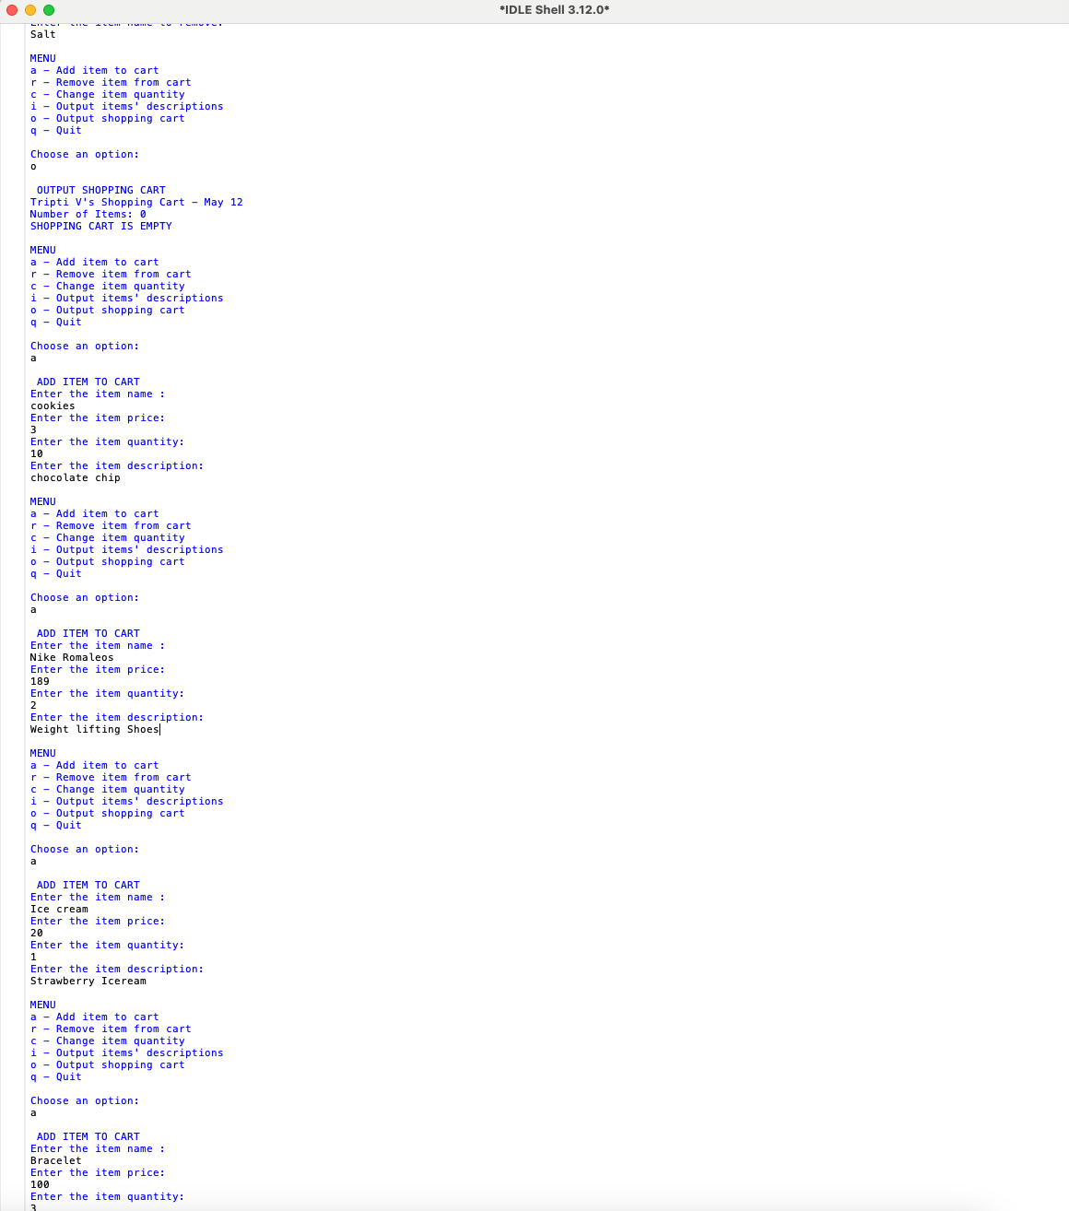
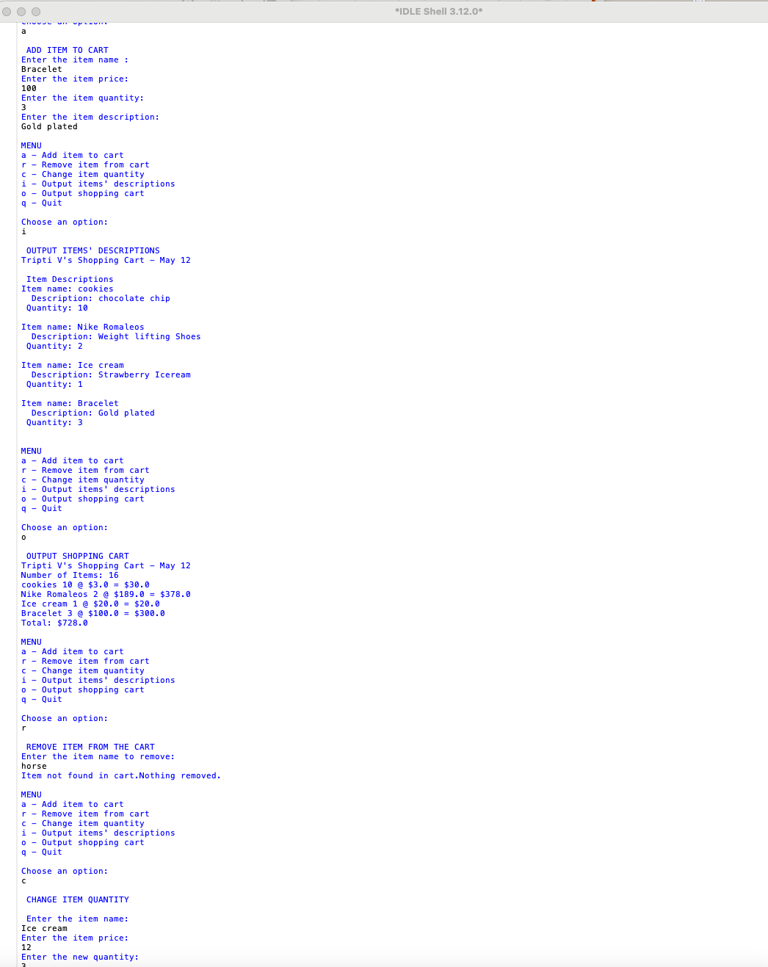

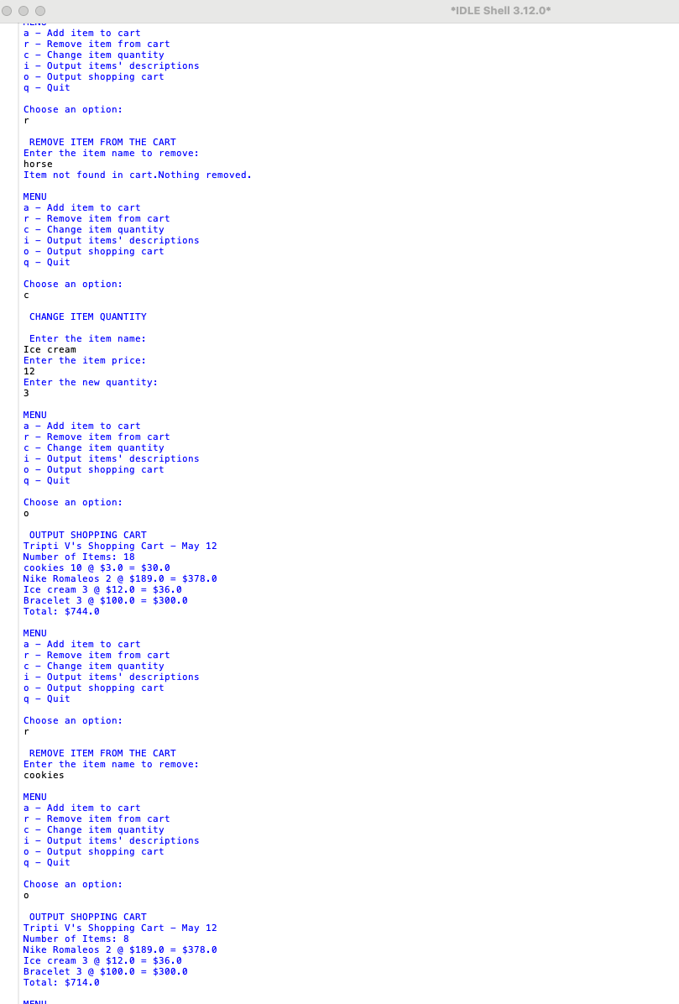
Link to Git Hub Repo-
https://github.com/triptiV1/module3/blob/main/CSU%20/Modules/CT%20Asgmts/Final_ProjectMilestone_%20Online%20Shopping%20cart.py

